Name _____________________________________________ Class ________________ Date _________________

Question Answer Relationship (QAR)
Directions: Use the QAR framework to label each question depending on where the answer is found. i.e. The answer to this question can be found “In The Book” or “In My Head”. Then, get even more specific by determining if the answer is “Right There”, “Think & Search”, “Author & Me” or “On My Own”.

“In The Book” |  | OR | “In My Head”  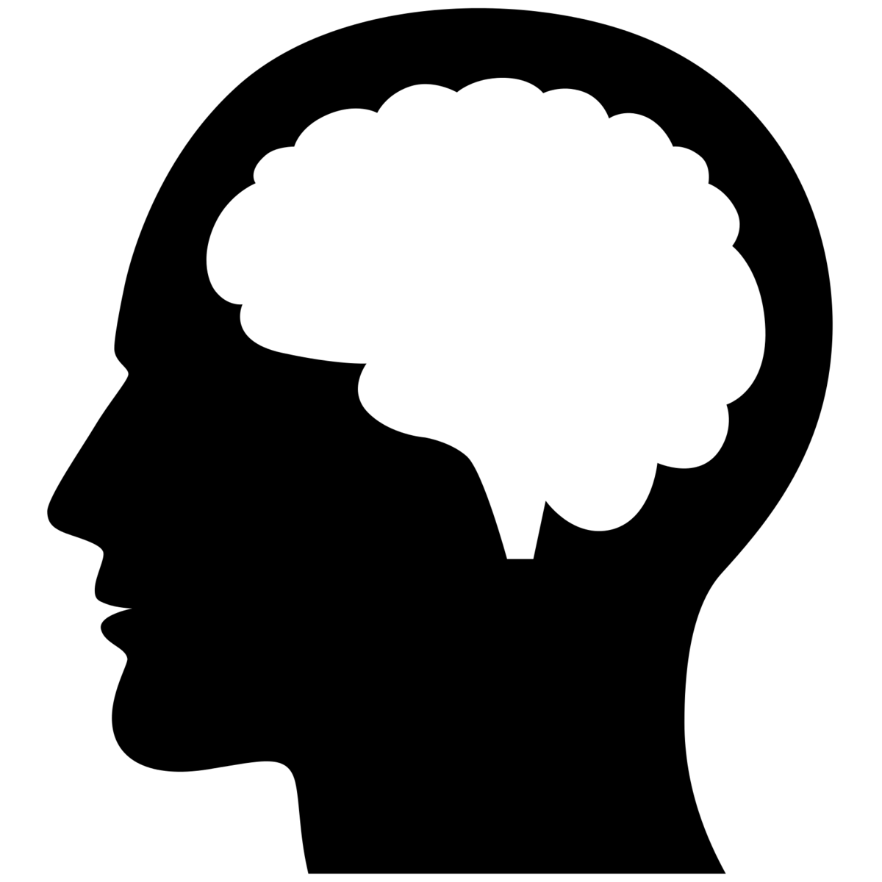
“Right There”  The answer is in the text, and if we pointed at it, we'd say it's "right there!" Often, the answer will be in a single sentence or place in the text, and the words used to create the question are often also in that same place. | “Think & Search”  The answer is in the text, but you might have to look in several different sentences to find it. It is broken up or scattered or requires a grasp of multiple ideas across paragraphs or pages. |  | “Author & Me”  The answer is not in the text, but you still need information that the author has given you, combined with what you already know, in order to respond to this type of question. | “On My Own”  The answer is not in the text, and in fact you don't even have to have read the text to be able to answer it.

